**Report on suscom.in to improve this website**

**Firstly, we have to choose which *CSM* is good by considering following reason :-**

* Use Angular 5 and Wordpress CMS
* Wordpress VS Joomla VS Drupal

|  |  |  |  |
| --- | --- | --- | --- |
|  | **Wordpress** | **Joomla** | **Drupal** |
| **Release Date** | 2003 | 2001 | 2003 |
| **Written In** | PHP | PHP | PHP |
| **No. of Websites** | 75M+ | 3M+ | 800K+ |
| **Themes & Templates** | 4.5k+ Free Themes  9.5k+ Premium Themes | No Free Themes  950+ Premium Templates | 2000+ Free Themes  450+ Premium Themes |
| **Ease To Use** | Easy to use | Easy to use | Coding Skills Required |
| **Plugins** | 50k+ Free Plugins  (Paid Plugins also available) | 75k+ Extensions  (Free & Paid) | 37k+ Drupal Module |

* Due to above comparison, it is clear that, **Wordpress** is more popular than **Joomla** & **Drupal.**
* All **CMS** are free & open source.
* Wordpress are use to create a website, blog 7 app.
* Joomla is use to create website and online application.
* Drupal is also use to create website and online application.
* All the above CMS are based on PHP & My SQL.

Now, What changes are improve website performance :-

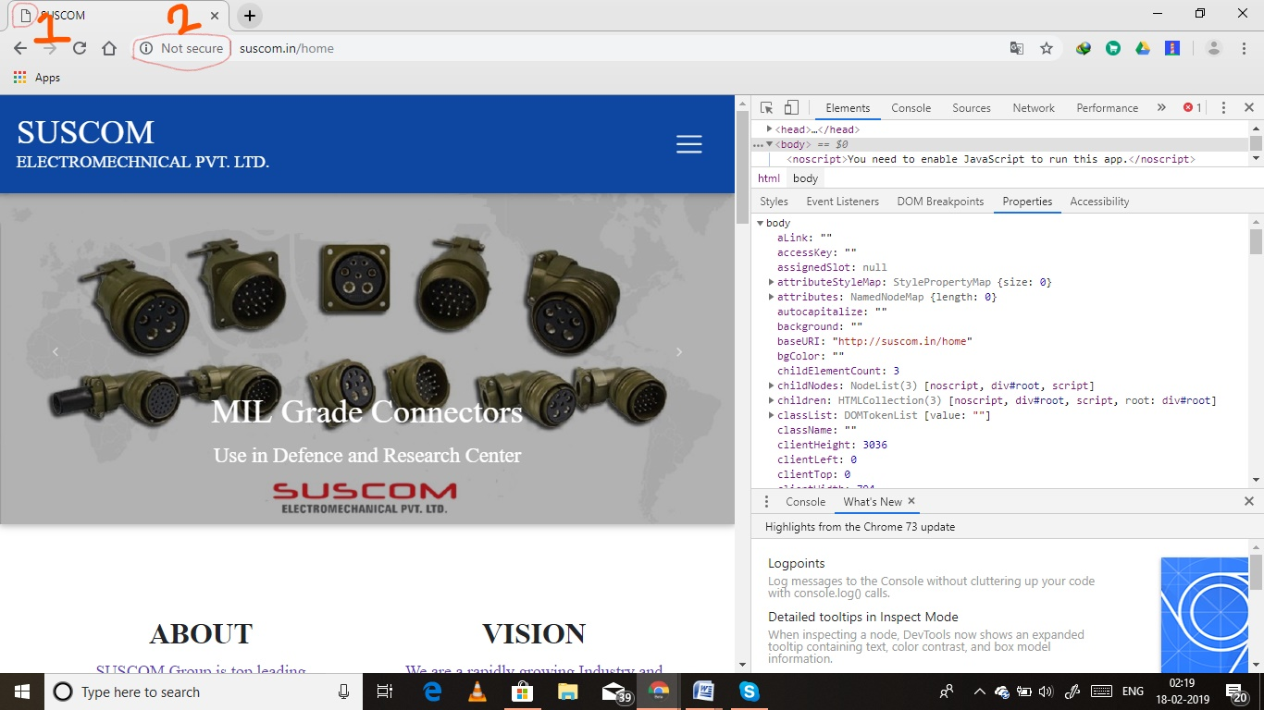

1. **Use Company logo.**
2. **Make Secure.**

**Use *https*.**

**Use <container>.**

**We can add price of product also.**

**Copyright Updation.**

**Images take more time to load (Use images in JPEG & PNG format ).**

**Improve ARIA (**Accessible Rich Internet Applications) **attributes. There are many errors.**

**Spelling Mistakes.**

**As per Lighthouse report, there are many errors in codes, HTML doctype is missing, not specified ratio for for images, application caches not used, ect.**

**Have to work on page indexing.**

* **By Mukeshkumar Gupta**